Darius Quick
7/22/25
Module Four Assignment One
First Severless Compute Function
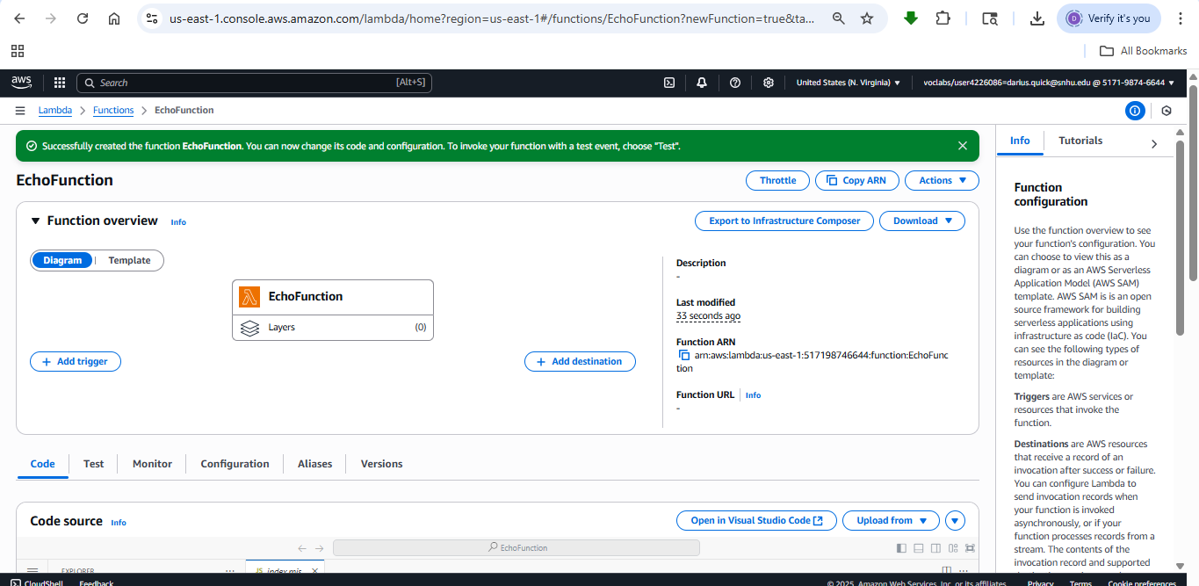
Test Execution Results
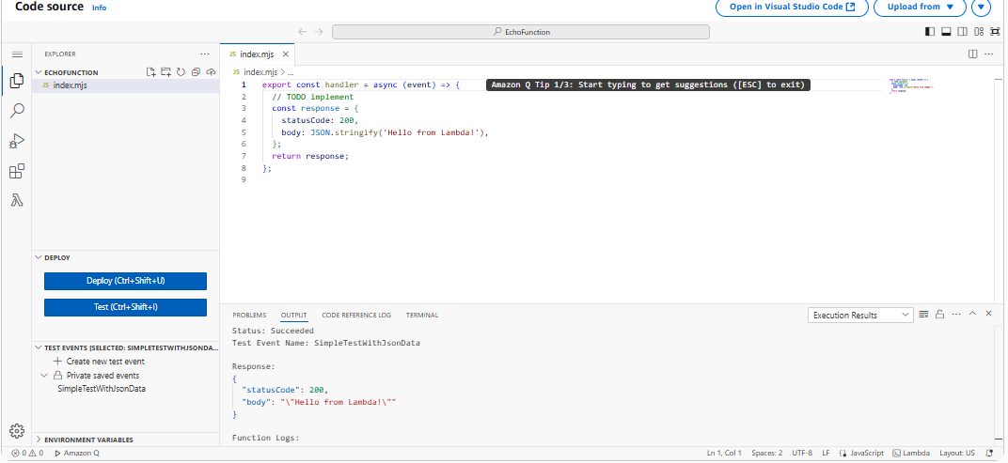
Test Execution Results Close Up
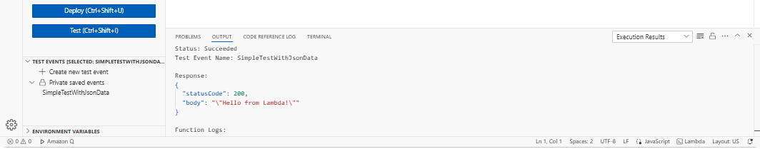
Execution Results
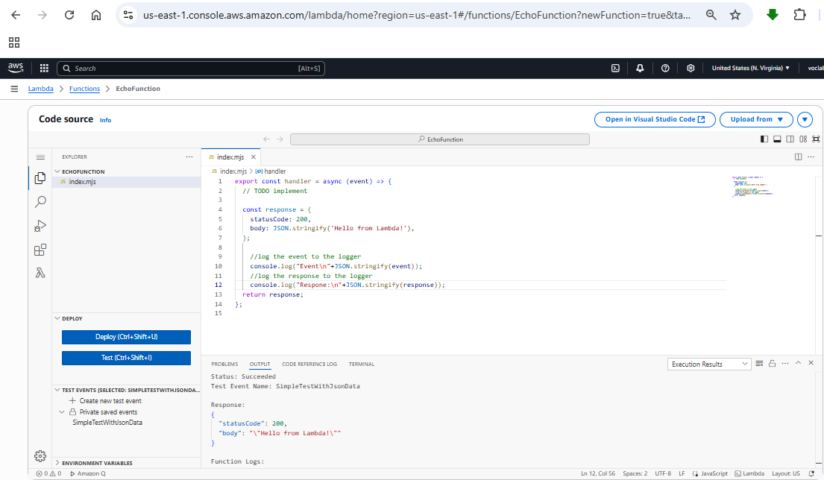
Execution Results Close Up
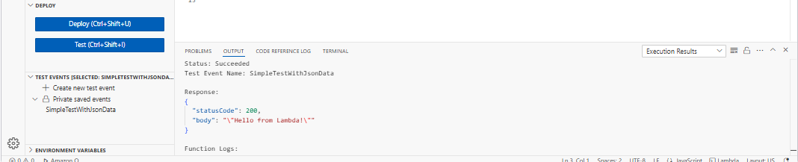
Execution Results Step 2
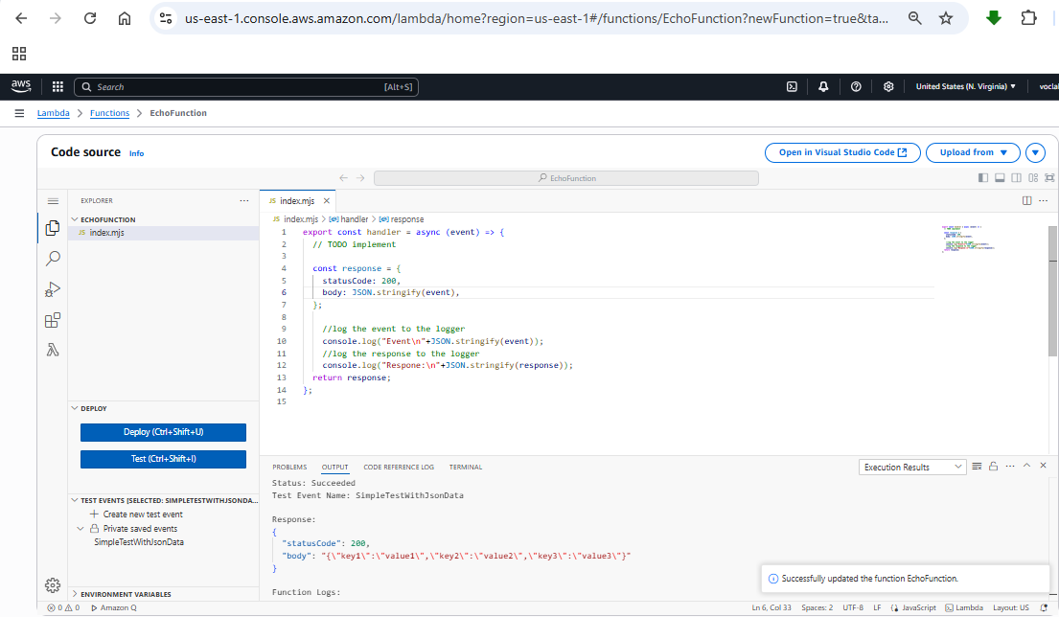
Execution Results 2 Close Up
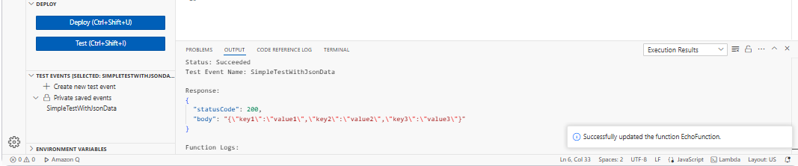
EchowithQuery Source Code
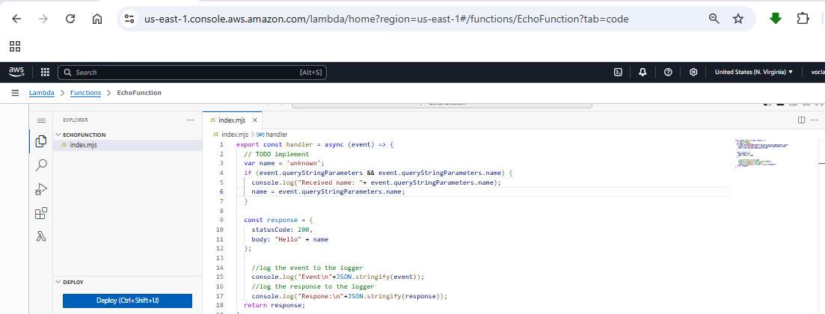
EchowithQuery Execution Results
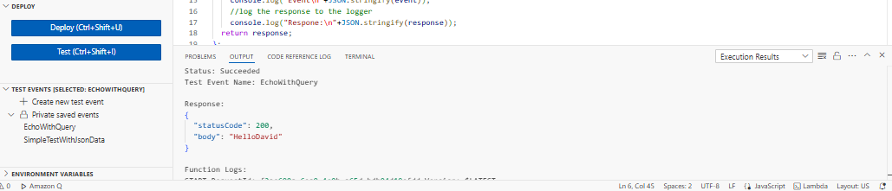
Screenshot for the creates test event EchoWithQuery
